Software Requirements Specification
for
KISLab
Version 1.0 approved
Prepared by Mohamed Hussein
January 6, 2017
Table of Contents
Table of Contents ii
Revision History ii
1. Introduction 1
1.1 Purpose 1
1.2 Document Conventions 1
1.3 Intended Audience and Reading Suggestions 1
1.4 Product Scope 1
1.5 References 1
2. Overall Description 2
2.1 Product Perspective 2
2.2 Product Functions 2
2.3 User Classes and Characteristics 2
2.4 Operating Environment 2
2.5 Design and Implementation Constraints 2
2.6 User Documentation 2
2.7 Assumptions and Dependencies 3
3. External Interface Requirements 3
3.1 User Interfaces 3
3.2 Hardware Interfaces 3
3.3 Software Interfaces 3
3.4 Communications Interfaces 3
4. System Features 4
4.1 System Feature 1 4
4.2 System Feature 2 (and so on) 4
5. Other Nonfunctional Requirements 4
5.1 Performance Requirements 4
5.2 Safety Requirements 5
5.3 Security Requirements 5
5.4 Software Quality Attributes 5
5.5 Business Rules 5
6. Other Requirements 5
Appendix A: Glossary 5
Appendix B: Analysis Models 5
Appendix C: To Be Determined List 6

Revision History
Name | Date | Reason For Changes | Version
Mohamed Hussein | 6-Jan-17 | created | 1.0.0

Introduction

Purpose
This document includes software requirements for KISLab, release number 1.0.0, this document follows the IEEE standard for software requirements specification documents.
KISLab is open source software distributed under the terms of GNU public license (GPL)
The purpose of this project is to provide an easy way to write codes and compile them through
Command line via terminal as it combines code editor and terminal in the same interface through
A simple graphical interface.

Document Conventions
• When writing this document it was inherited that all requirements have the same priority.
• First there is presented an overall view about KISLab and then all features and functions are
Analyzed in detail

Intended Audience and Reading Suggestions
This Software Requirements document is intended for:

Developers: in order to be sure they are developing the right project that fulfills requirements provided in this document.

Testers: in order to have an exact list of the features and functions that has to respond according to requirements and provided diagrams.

Users: in order to get familiar with the idea of the project and suggest other features that would make it even more functional.

Documentation writers: to know what features and in what way they have to explain, how the system will response in each user’s action etc.

Advanced end users, end users/desktop and system administrators: in order to know exactly what they have to expect from the system, right inputs and outputs and response in error situations.

Product Scope
KISLab is simple development tool that combine code editor and terminal window in the same application, which mean that you can write your own code and compile and run it directly from terminal window without having to open external or system terminal
It provides simple GUI implementing the principle of our software name KIS ,keep it simple ,it also provide the user with all functionalities needed to handle source files

References
More about KISLab can be found at

- https://sourceforge.net/p/kislab

In this website you can find out more about the project and discuss any questions in the forums. You
can go back and look at previous releases, code and problems that have been solved. There you can
also find information about the developers as well as the project’s main characteristics such as
Programming language and algorithms

- https://github.com/mo7amed-hussein/KISLab

This is repository of the project

Overall Description

Product Perspective
KISLab is tool for software developer, it combine between code editing and compile using terminal from the same tool in simple and easy way ,although there are many tools for developing software like IDE’s ,our program offer way for those who like to compile and run their codes from terminal
Although our program is very simple and easy to use unlike many other IDE which are very complex.

Product Functions
The basic version provides the user with following features:

- Source files: new, open, save, save as, save a copy as, save all, close, close all, multiple tabs.
- Editing codes :
  - Undo, redo, copy , paste , cut , delete , select all
  - Copy to clipboard either filename, full path or directory
  - Convert case to upper and to lower
  - Comment and uncomment either to single line or block of code
  - Time/date print
  - Search
- Autocomplete support
- Compile and run from terminal window embedded in our program
- Colored source codes
- maintain list of recent opened files only last 6 files
- drag and drop capability
- dim off the screen around the editor window

User Classes and Characteristics
- Developers

Operating Environment
KISLab should be run on Linux OS .

Design and Implementation Constraints
KISLab is written with c++ programming language, it’s user interface implemented using qt library, so anyone who wishes to work on further development of KISLab has to know those tools .
KISLab is GNU GPLv3 licensed, everyone, that does or is going to develop or use KISLab, should agree and fully accept the terms of this kind of license

User Documentation
By downloading KISLab, the user also gets a compiled HTML Help file with a tutorial and full help on all features provided.

Assumptions and Dependencies
Any pc running Linux OS.

External Interface Requirements

User Interfaces
KISLab is simple GUI, the following image show general view for it.
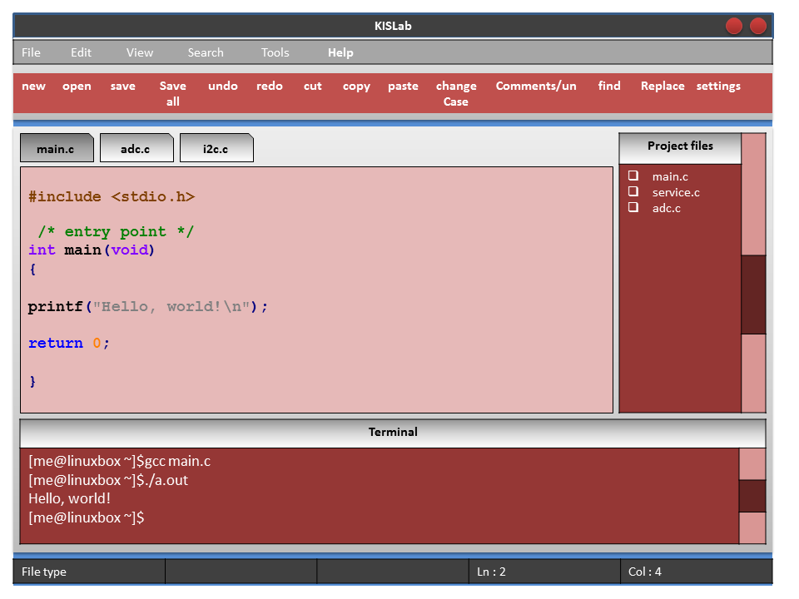

Main Menu

File menu
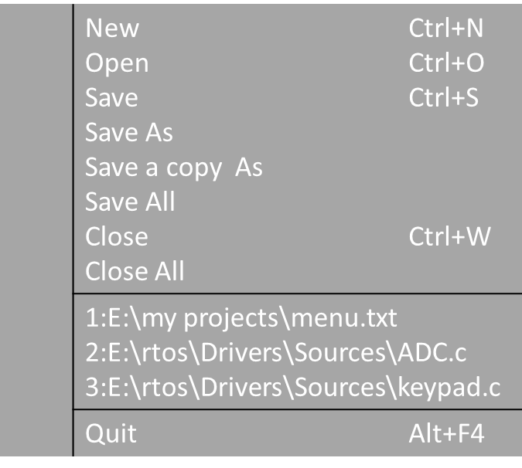

Edit menu
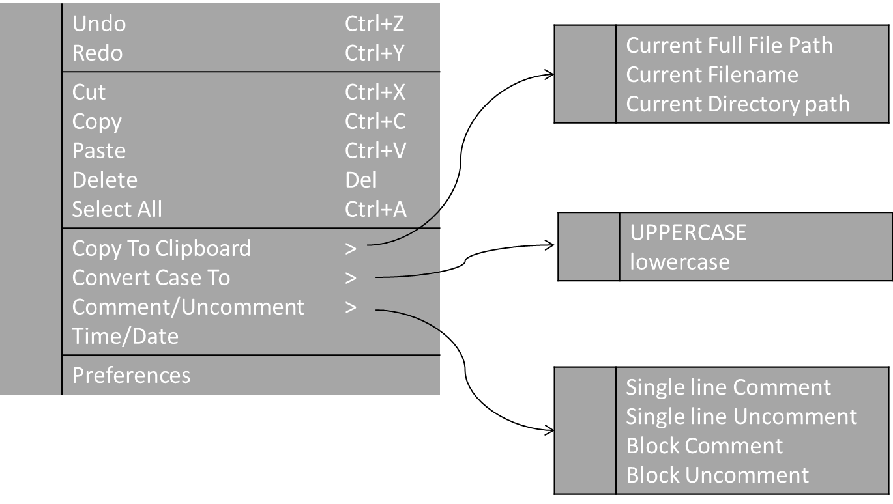

View menu


Search menu
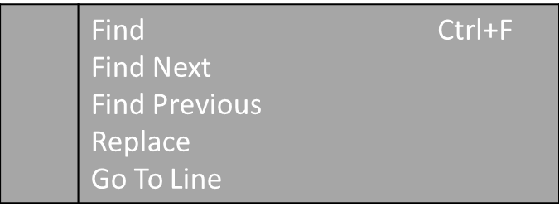

Tools menu



Help menu


Mouse right menu:

Tab popup menu
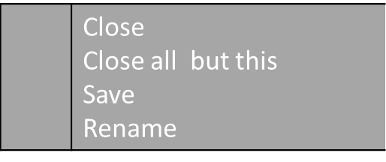

Source code popup menu
As edit menu

Project files popup menu
As Tab popup menu

Terminal popup menu
As normal terminal menu

Dialogs:

new file :
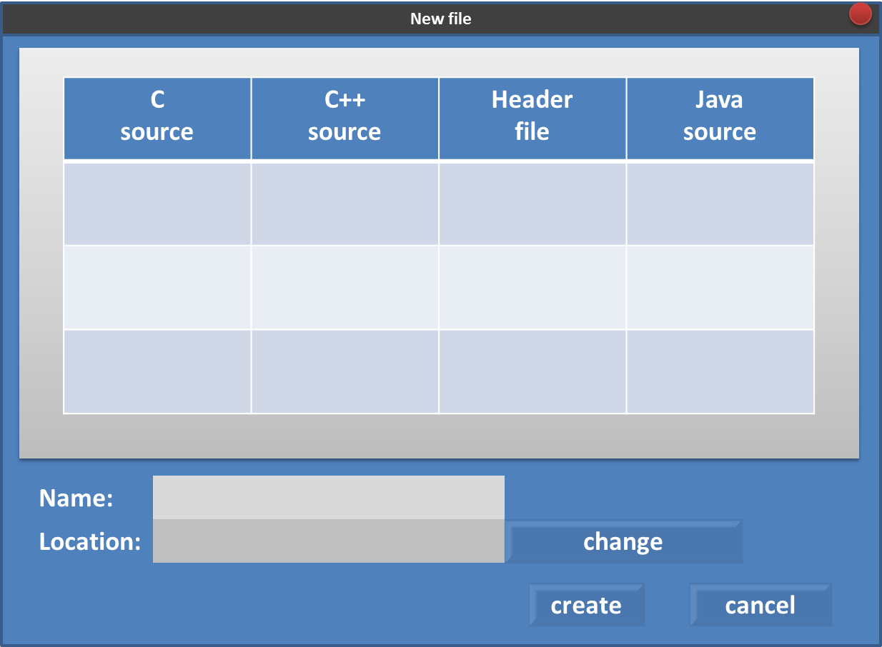

Open file:
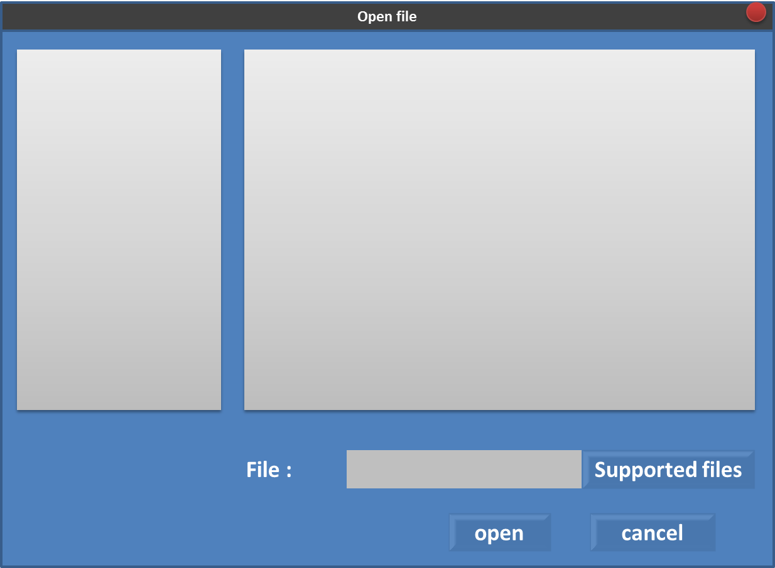

Save file:
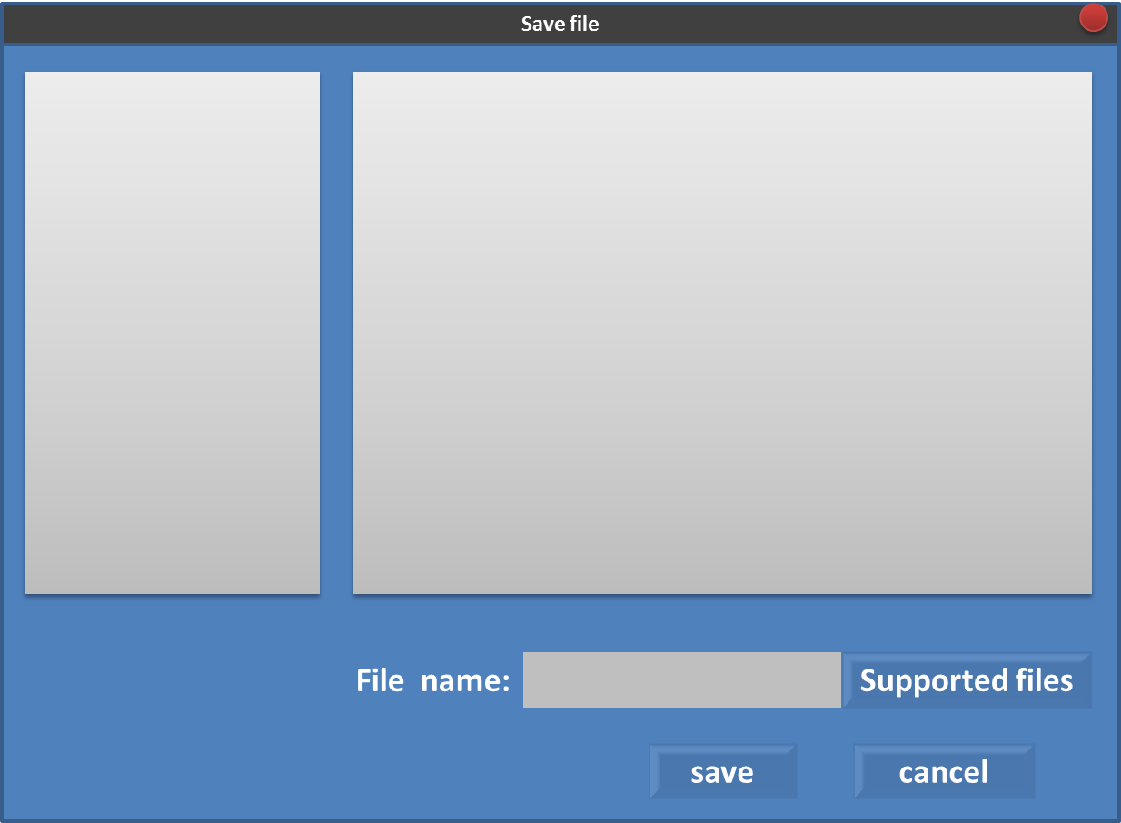

Close file: if changes didn’t saved
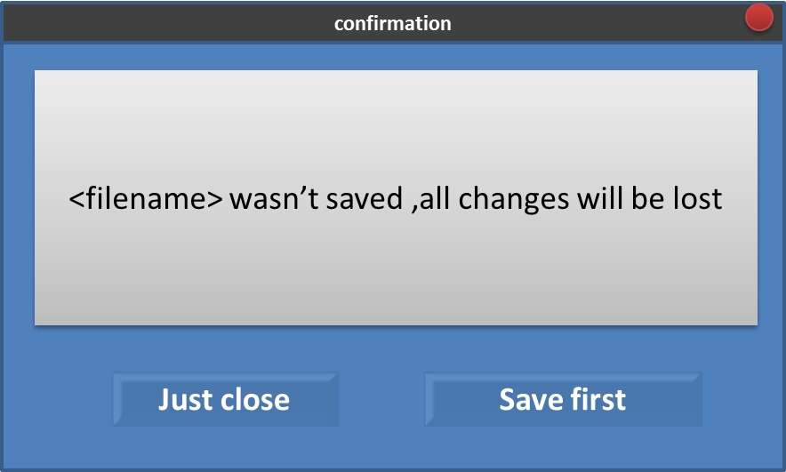

Close file /quit Confirmation:
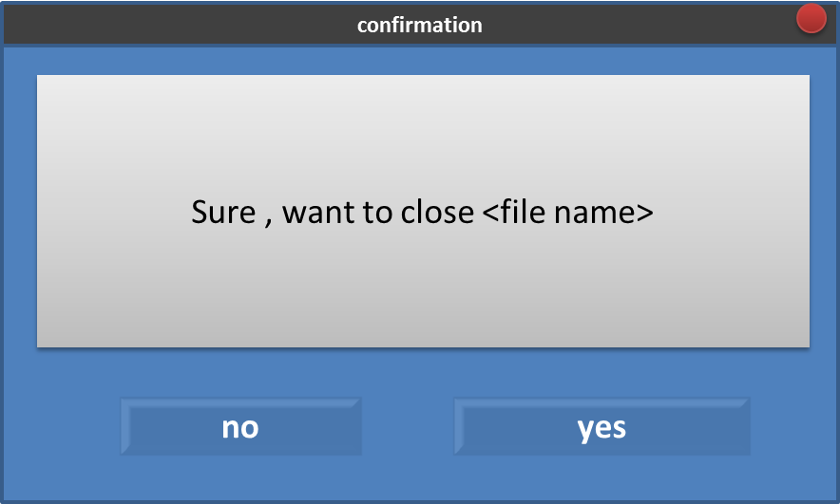

Preferences dialog:
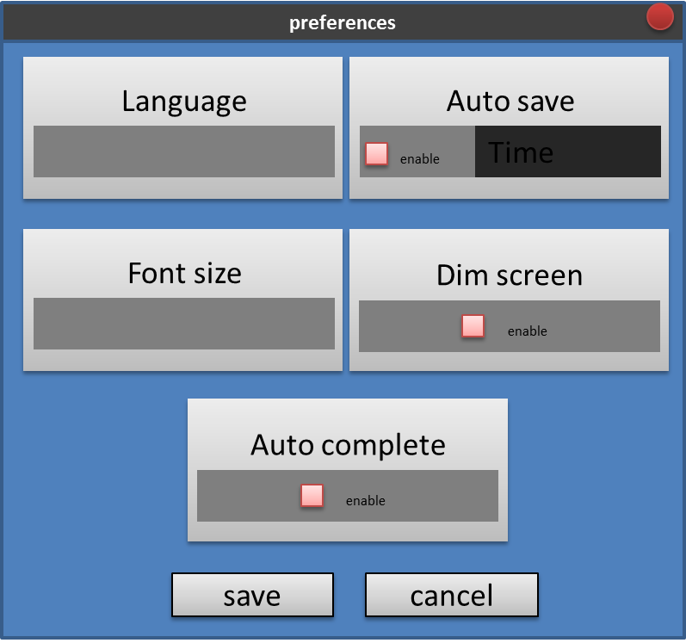

Find dialog:
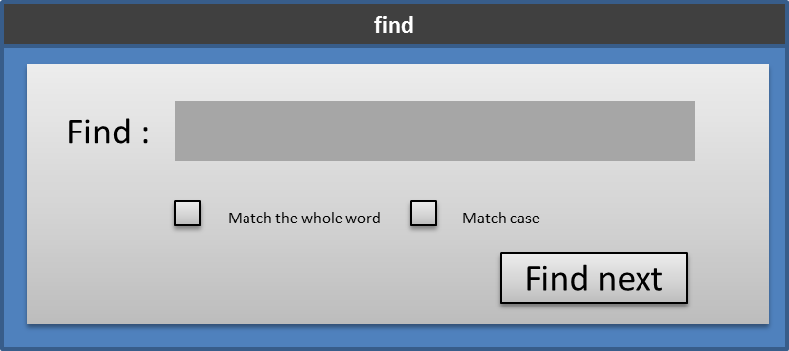

Replace dialog:
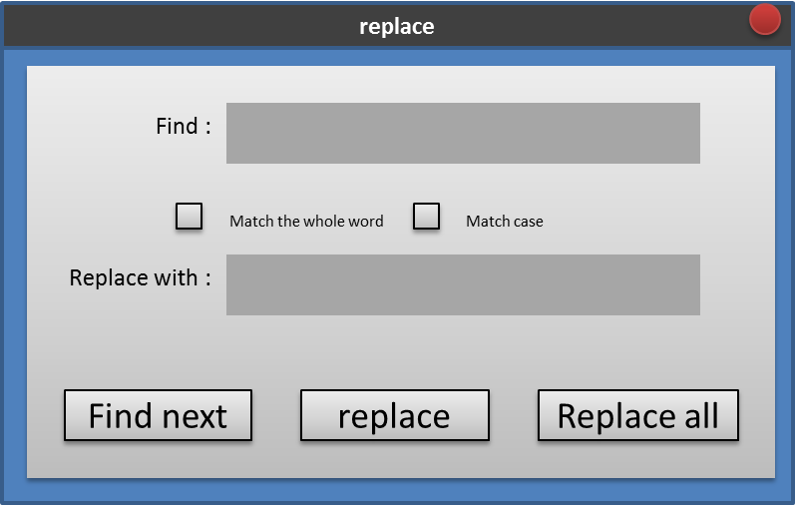

Go to line dialog
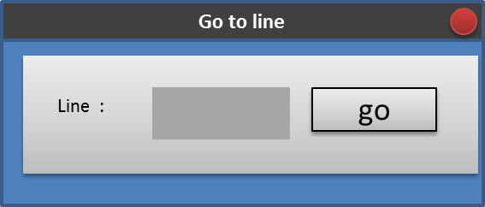

File statistics dialog
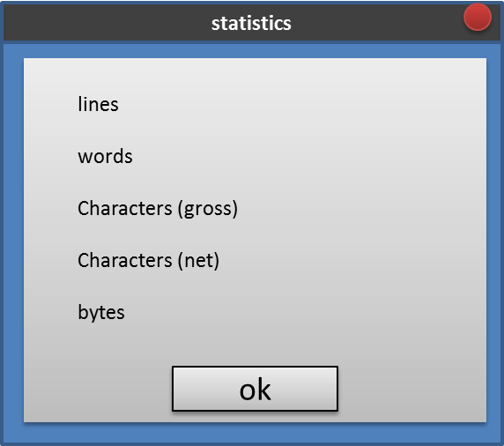

About dialog

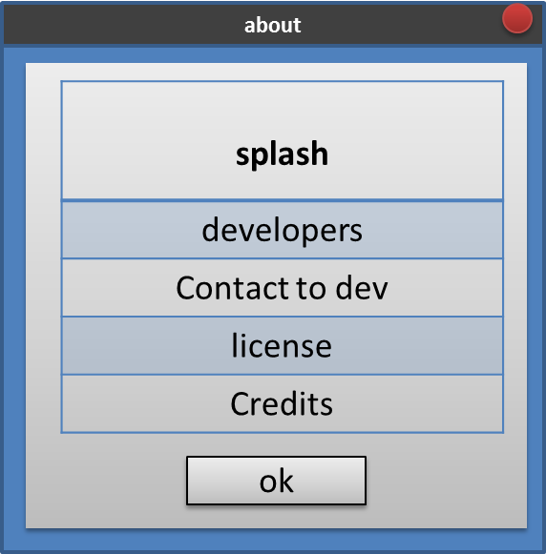

Hardware Interfaces
N/A.

Software Interfaces
KISLab should only on any pc running Linux operating systems.

Communications Interfaces
KISLab isn’t web application ,so our program doesn’t need to network in the first release.

System Features
KISLab has set of features as follow

New source file
Description | The user can create new source file
Stimulus/Response Sequences | - User select new from toolbar or from file menu  - User select file type from new file dialog  - User enter filename and storage directory  - File is opened in new tab containing template according to file type
Functional Requirements | N/A

*file types are sorted according to most recent use

4.2 open a file

Description | The user can open source file (only files supported by scintilla)
Stimulus/Response Sequences | - User select open from toolbar or from file menu  - User browse to file location  - User select file supported  - File is opened in new tab
Functional Requirements | REQ-1: Only files supported by scintilla can be opened

*browser starts with most recent directory and contain list of all the most common directories.

4.3 save a file
Description | The user can save source file
Stimulus/Response Sequences | - User select save from toolbar or from file menu  - User browse to file save location(if it is first time)  - File saved
Functional Requirements | REQ-1: there is and opened file  REQ-2: file must be modified first

4.4 close a file
Description | The user can close opened source file
Stimulus/Response Sequences | - User select close from toolbar or from file menu  - User asked to save first if it was not  - File closed
Functional Requirements | - REQ-1: there is an opened file  - REQ-2: User asked to save first if it was not

4.5 control changes history
Description | The user can undo / redo changes
Stimulus/Response Sequences | - User select undo/redo from toolbar or from edit menu
Functional Requirements | - REQ-1: there is an opened file  - REQ-2: changes already made ,or on affect

4.6 edit source codes
Description | The user can copy, cut, delete, paste, select all
Stimulus/Response Sequences | - User select text first in case of copy or cut or delete  - User select operation either from edit menu or from right mouse menu or from toolbar
Functional Requirements | - REQ-1: there is an opened file

4.7 copy to clipboard
Description | The user can copy filename or directory or file path to directory
Stimulus/Response Sequences | - User select one of those functions from edit menu
Functional Requirements | - REQ-1: there is an opened file

4.8 change case
Description | The user can change text case either to upper or to lower
Stimulus/Response Sequences | - User select text first  - User select change needed either from toolbar or from edit menu or from right mouse menu
Functional Requirements | - REQ-1: there is an opened file  - REQ-2: select text first

4.9 search and replace
Description | The user can find and replace text in opened files
Stimulus/Response Sequences | - User select find or replace from toolbar or from search menu  - User set text to search for  - Results appear according to precedence
Functional Requirements | - REQ-1: there is an opened file  - REQ-2: file isn’t empty

4.9 comment /uncomment code
Description | The user can comment /uncomment code
Stimulus/Response Sequences | - User select text first  - User select comment /uncomment either from toolbar or from edit menu or from right mouse menu
Functional Requirements | - REQ-1: there is an opened file  - REQ-2: file isn’t empty

4.10 compile and run
Description | The user can compile and run codes from terminal
Stimulus/Response Sequences | - User type compile script in terminal window
Functional Requirements | - REQ-1: there is an opened file  - REQ-2: file isn’t empty

4.10 autocomplete code

4.11 colored code

4.12 drag and drop for open files

4.13 keep recent files path in file menu

4.14 dim off the screen
Screen around editor widow will be dimmed off automatic when it get focus , and can be disabled

Other Nonfunctional Requirements

Performance Requirements
KISLab is an application that needs a few system resources to work. This is designed not to
delay the system from other key processes.

Safety Requirements
KISLab should ensure that it leaves untouched the input source files. No modification is allowed to those files.

Security Requirements
KISLab does not introduce any security level, since the data it manages is not critical. The users
in the application are all equal so there is not the need of any identity management level

Software Quality Attributes
This application provides a pleasant and user friendly graphical interface with relatively simple
functions. Any user should be able to use KISLab without any specific knowledge or experience
by reading the user manuals (or the help messages that are embedded in the application). Users
only need to provide some source codes files and with just a few clicks they can perform any action

